Labview Potentiometer Testing and Calibration

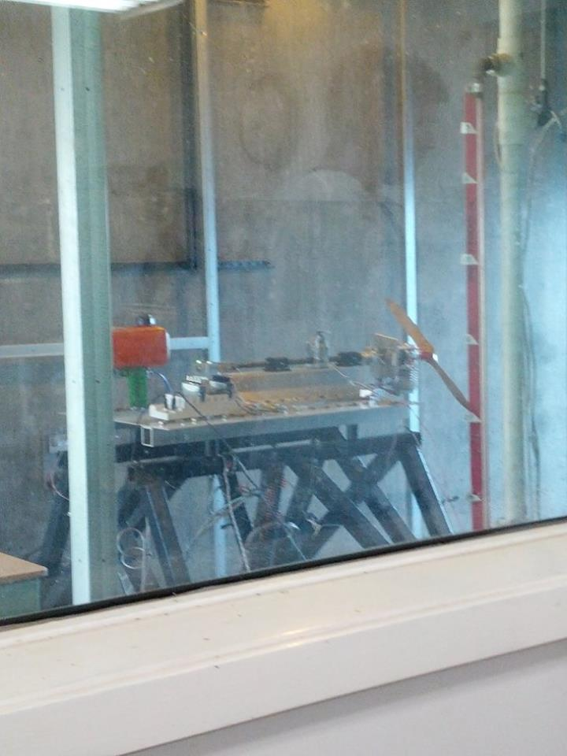



Elizabeth O’Neil

Instructor: Dr. Haiyang Chao

Department of Aerospace Engineering

February 4, 2014

# Abstract

The purpose of this experiment was to develop a model of the relationship between angular rotation of a potentiometer and the resulting voltage output. This relationship was determined using Labview to create a virtual voltmeter. Several tests were performed to identify the system, after which several data sets were collected. The data collected in this experiment allowed the determination of the linear relationship between angular rotation and output voltage for the potentiometer. This linear relationship allowed the angular roation to be determined for an arbitrary voltage reading.

# Acknowledgements

For the use of their facilities and resources, I would like to thank the University of Kansas Department of Aerospace.

Table of Contents

Page #

Abstract ii

Acknowledgements iii

List of Figures v

List of Tables vi

1 Introduction 7

2 Experimental Apparatus 8

2.1 Experimental Procedure 8

3 Experimental Results 10

3.1 Data Results 10

3.2 Interpretation of Results 13

3.3 Sources of Error 14

4 Conclusions 14

5 References 15

6 Appendix I 16

# List of Figures

Page #

Figure 1: Desert Aircraft 50cc1 7

Figure 2: Engine on Test Stand 8

Figure 3: RPM Measurement 9

Figure 4: RPM vs. Throttle Percent 11

Figure 5: Throttle Percent vs. Time 11

Figure 6: Thrust vs. Time 12

Figure 7: Torque vs. Time 12

Figure 8: Horsepower vs. Time 13

Figure 9: Horsepower vs. RPM 13

# List of Tables

Page #

Table 1: Engine Specifications 7

Table 2: RPM Data 10

# Introduction

The purpose of this experiment was to use a virtual voltmeter to determine the relationship between angular roation and output voltage for a potentiometer, shown in Figure 1. In addition to determining the mathematical relationship between angular rotation and voltage, this experiment functioned as an introduction to the Labview environment.

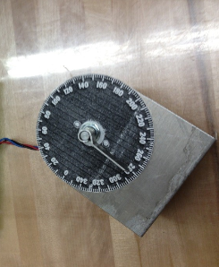

Figure : Potentiometer

## Potentiometer Operation

Potentiometers are resistors that are able to provide variable resistance based on user input. Devices such as knobs or sliding switches allow a contact to move along a resistive material, changing the resistance that the potentiometer provides in the circuit. Due to the change in resistance, the voltage drop across the potentiometer changes according to Ohm’s Law, shown in equation 1.

$$V=IR$$

**Equation 1**

A circuit diagram of a potentiometer is shown in figure 2, with a picture of the potentiometer used shown in figure 3.

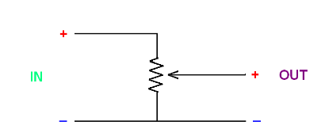

Figure : Potentiometer Operation

## Labview Operation

In order to view the output of the potentiometer, a voltmeter was constructed in Labview to take the place of a conventional multimeter. In order to establish I/O flow between the potentiometer and the PC, the NI CB-68 LP I/O board was used.

# Experimental Apparatus

Before starting this experiment, each lab bench was provided with a potentiometer that had a rotation knob. Each station was also provided with a PC, an NI CB-68 LP I/O board, and a 6024-E to allow interface between the potentiometer and the Labview software on the PC.

## Experimental Procedure

In order to measure the potentiometer voltage, a virtual sensor was set up in the Labview environment. This virtual voltmeter was configured to display digital output and to be controlled by a simple on/off switch that would trigger power and measurement from the PC. The virtual voltmeter is shown in figure 3.

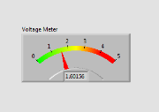

Figure : Virtual Voltmeter

The potentiometer was connected to the I/O board as detailed in table 1.

Table : Potentiometer Wiring

|  |  |  |
| --- | --- | --- |
| Potentiometer |  | NI CB-68 LP I/O |
| Ground | Black | Pin 34 (AI 8) |
| Ground | Black | Pin 35 (D GND) |
| Signal | Blue | Pin 68 (AI 0) |
| Power | Red | Pin 8 (5V) |

After the connection had been validated, 10 data sets were collected for angular rotations from 0 to 180 at intervals of 20 degrees. After this data had been recorded, 10 additional data sets were recorded for angular rotations of 30, 60, and 90. After recording all data, the potentiometer was disconnected from the I/O board and the Labview software was closed.

# Experimental Results

After all of the data was recorded, the data was entered into excel in order to construct graphs. All excel spreadsheets can be found in Appendix A. The trendline function in excel was used to determine the linear function that governed the potentiometer’s operation.

## Data Results

The results from the system identification data collection is summarized in figure 4. The trendline function for the first three data sets is shown above the legend. Although there were minute variations between each data set, each trendline was identical to several decimal places. Equation 2 summarizes the results of the systems identification.

$$V (Volts)=0.019θ(degrees)+ .1$$

**Equation 2: Potentiometer Model**

## 

Figure : System Identification Data

Figure 5 summarizes the results from the second set of data collection. Again the curve fit equation for the first three data sets are shown above the legend.

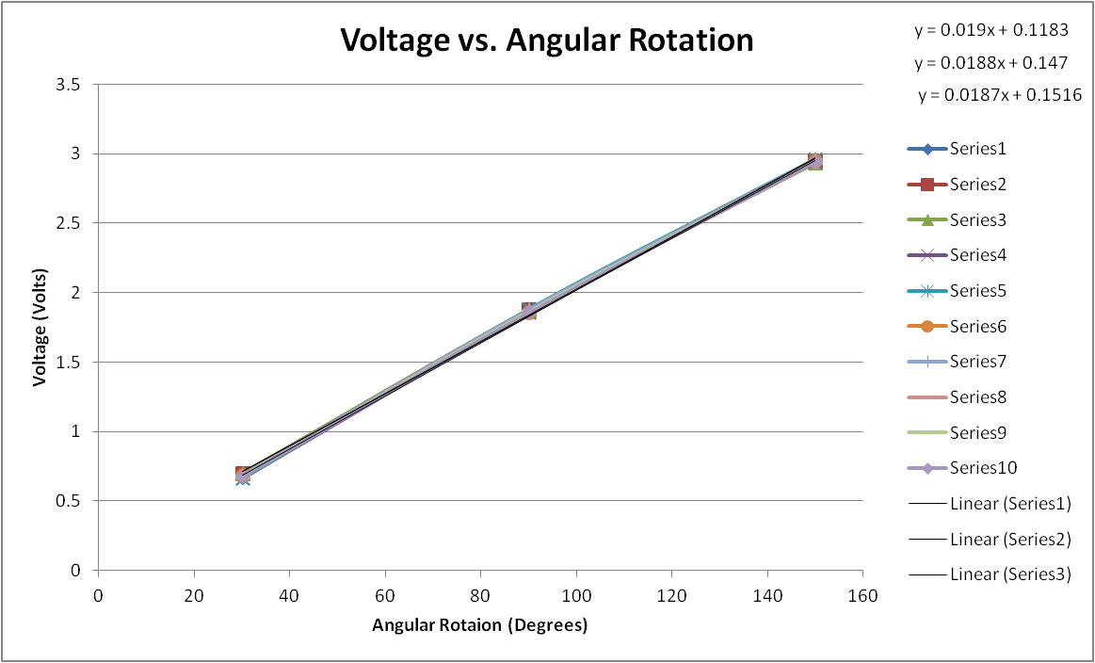

Figure : Validation Data

## Interpretation of Results

## Sources of Error

Although fairly modern equipment was used for this experiment, there are always possible sources of error in any experiment. The input system is most likely the largest source of error, as the manual level for input could easily have been off from the intended value by a degree or two. Additionally, faulty wiring or bad connections could have introduced noise into the procedure. The conversion from analog signal to digital signal that took place in the PCI 6024E could have introduced small errors as well. However, the close correlation between the data sets suggests that the experiment was relatively free of error.

## Lab Questions

* See equation 2 and the results in section 3.1.
* According to the equation determined from the first round of data, which was 0.693, 1.875, 2.949 volts, respectively. According to equation 2, this would correspond to angles of 31.2, 93.1, and 149.9. The angles that were entered to the potentiometer were 30, 90, and 150. The percent differences for the approximation is 4%, 3.4%, and .067%. The minor differences between the predicted and actual angles is most likely due to the inaccurate angle entry system. User error probably led to the discrepancy.
* In this situation, signal + should be connected to pin 64 with the signal – connected to pin 30.
* Pins 14 (power) and 39 (ground) could be used instead. The potentiometer power would be connected to 14 with ground connected to 39.
* Using Labview gives the user a lot of flexibility to design an ideal sensor. The sensor can be easily modified to measure other quantities. The range can be changed, as well as the sensitivity. Unlike a multimeter there is much less of a chance of the connection being broken.

# Conclusions

This experiment allowed the verification of established engine relationships. This data shows the positive correlation between throttle percent and RPM. Additionally, it shows that both throttle percent and RPM are positively correlated with thrust, torque, and horsepower. The data verified the predicted power output of the engine to 14% accuracy, which is reasonable considering how drastically elevation and other external factors can influence engine power.

The results of this experiment could be used to program a throttle controller for this engine to prevent developing too much or not enough power during flight. Additionally, the thrust data could give some insight into the problem with the sensor. After fixing the sensor, this experiment could be repeated to verify expected thrust trends.

# References

1. Desert Aircraft, “DAR-50-R.” <http://www.desertaircraft.com/engines_detail.php?Page=DA-50-R> , Accessed on 13 November 2013

# Appendix I

%script to generate graphs for engine data

importfile('DATA.mat')

time2=DATA.run2(:,1);

throttlepercent2=DATA.run2(:,2);

thrust2=DATA.run2(:,3);

torque2=-1.*DATA.run2(:,4);

RPMdata=xlsread('RPM.xlsx');

throttleRPM=RPMdata(:,1);

RPM2=RPMdata(:,3);

%horsepower calculation- horsepower can be calculated from a torque in

%in-lbs and an RPM as (2*pi*torque*12*rpm)/(33000)

%Because no continuous RPM data is given that corresponds with the torque

%data, the throttle percent given in the main DATA file was correlated with

%the average RPM for a given throttle percent from the RPM data and used to

%estimate the RPM at a given throttle percent.

%avg rpm for given throttle percent

RPMavg=[20 40 60 80 100;(3030+2200)/2 (4320+3840)/2 (5340+6550)/2 (7050+6870)/2 7050];

%Initializes arrays

HP2=zeros(1, length(throttlepercent2));

RPM2_2=zeros(1,length(throttlepercent2));

%for each row of data, this loop determines the nearest throttle percent

%data, assigns this value to RPM2_2 for the same index, and uses the value

%to calculate horsepower at the same index.

for i=1:length(throttlepercent2)

for j=1:5

if throttlepercent2(i) < RPMavg(1,j)+15

RPM2_2(i)=RPMavg(2,j);

HP2(i)=(2.*pi.*RPM2_2(i).*torque2(i))./(12*33000);

break;

end

end

end

%Creates necessary graphs

figure

plot(1:length(time2), throttlepercent2);

title('Throttle % vs. Time')

xlabel('Time (s)')

ylabel('Throttle %')

figure

plot(1:length(time2), thrust2);

title('Thrust vs. Time')

xlabel('Time (s)')

ylabel('Lbs')

figure

plot(1:length(time2), torque2);

title('Torque vs. Time')

xlabel('Time (s)')

ylabel('in-lbs')

figure

plot(1:length(time2), HP2);

title('Horsepower vs. Time')

xlabel('Time (s)')

ylabel('HP')

figure

plot(RPM2_2(1:length(time2)/2), HP2(1:length(time2)/2), 'r');

title('Horsepower vs. RPM')

xlabel('RPM')

ylabel('HP')

hold on

plot(RPM2_2(length(time2)/2:length(time2)), HP2(length(time2)/2:length(time2)), 'b');

legend('Throttling Up', 'Throttling Down')

hold off

figure

plot(throttleRPM(1:5), RPM2(1:5),'r');

title('RPM vs. Throttle Percent')

xlabel('Throttle %')

ylabel('RPM (rev/min)')

hold on

plot(throttleRPM(6:9), RPM2(6:9), 'b')

legend('Throttling Up', 'Throttling Down')

hold off